FRACTION IDEAS PRACTICE TEST
- Draw a circle divided into 6 equal parts. Shade 5 of those parts.

What fraction of the circle is shaded? ______________________

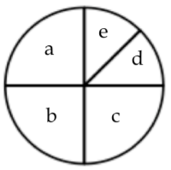
What fraction of the circle is a? ______________
What fraction of the circle is a, b and c combined?___________
What fraction of the circle is e?_____________

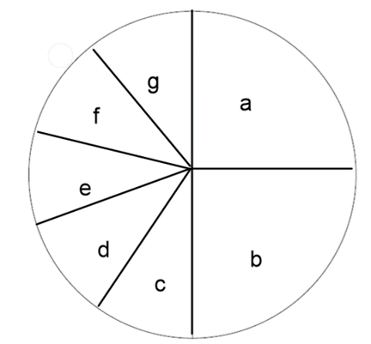

What fraction of the circle is a? ______________
What fraction of the circle is c,d,e,f,and g combined?___________
What fraction of the circle is g?_____________

- You want to share your pan of brownies equally among yourself and your 8 friends. Draw a picture of your pan of brownies showing how you would divide it up to share.

What fraction of the pan will each get? ____________________

- Circle the larger fraction. Explain your thinking for each example.

$\frac{2}{4} \frac{2}{3}$ _____________________________________________________________________________

$\frac{1}{10} \frac{1}{20}$ ____________________________________________________________________________

$\frac{4}{5} \frac{2}{5}$ ____________________________________________________________________________

$\frac{3}{9} \frac{6}{9}$ ______________________________________________________________________________

- Give two fraction names for the shaded amount in each picture. You may draw on the pictures to help you find equivalent fractions.

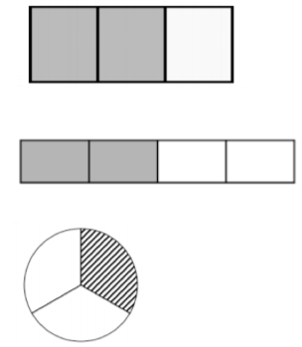
_________ __________

_________ __________

_________ __________

- Find equivalent fractions. You may use your fraction circles to find equivalent fractions.
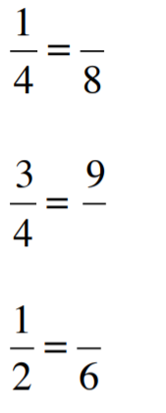

- Draw a picture of chips (or tiles) to show each fraction below. Use 8 chips as the unit for each example.
- How many fifths are shaded?
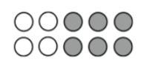

______________

- Give three fraction names for the amount shaded.
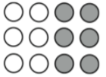
________________

________________

________________

- Draw a picture of $\frac{1}{3}$ using 12 chips (or tiles). What is another fraction amount for the picture drawn?

Another fraction name ________________

- If the whole circle is the unit, name the amount shaded in two different ways.

_________________

_________________

- Draw a picture to show $\frac{6}{4}$. Name that amount using a mixed fraction.

Name as a mixed fraction _____________

- List three fractions equal to $\frac{1}{2}$.

_________ __________ __________

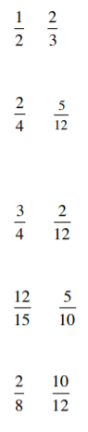
- Circle the larger fraction in each pair:

- Challenge: Which is bigger: $\frac{3}{4}$or $\frac{2}{3}$ ? Explain your thinking.

- Use fraction circles to solve this problem. Draw a picture of what you did with the circles.

$$\frac{3}{4} + \frac{1}{8}$$

- Use fraction circles to solve this problem. Draw a picture of what you did with the circles.

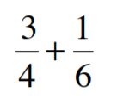
Picture

Answer ______________

- Use fraction circles to solve this problem. Draw a picture of what you did with the circles.

$$\frac{3}{4} - \frac{3}{8}$$

Picture

Answer ______________

- Use your fraction circles to solve this problem. Draw a picture of what you did with the circles.

Alex needed $\frac{3}{4}$cup of sugar to bake cookies. When he measured out the sugar, he had only $\frac{1}{2}$ cup of sugar. How much more sugar did he need?

Pictures

Answer _______

- Ty noticed that there was $\frac{6}{8}$ of a pizza left over. He ate an amount equal to $\frac{1}{4}$ of the pizza. How much of a whole pizza was left? Use your fraction circles to solve and draw a picture of what you did.

Pictures

Answer _______

- Is the answer to this problem greater than one or less than one? Explain your thinking.

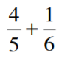

Explanation

- Is this a reasonable answer? Explain your thinking.

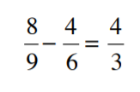
Explanation

