Chapter 5 Practice Test

Do not use a calculator for this test.

*For #1 to #5, circle the best answer.*

**1.** What is  as an improper fraction?

**A  B ** **C ** **D **

**2.** What is  as a mixed number?

**A**  **B**  **C**  **D** 

**3.** Which expression does the fraction strip represent?

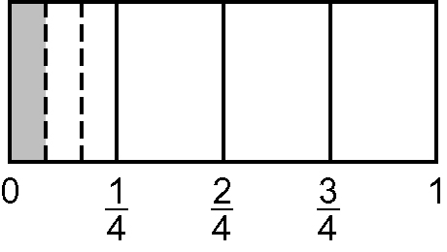

**A**  **B**  **C**  **D** 

**4.** Which expression does the number line represent?

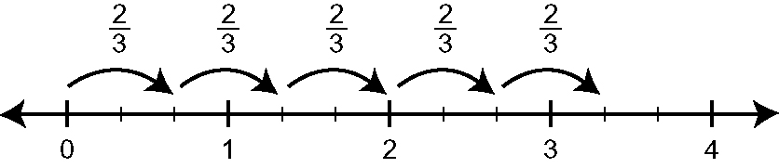

**A**  **B**  **C**  **D **

**5.** Which expression has  as an answer?

**A**  **B**  **C**  **D** 

**Short Answer**

**6.** Draw a diagram to model this division. In your own words, explain the diagram.



**7.** Evaluate.

**a)**  **b)**  **c)** 

**d) ** **e)**  **f)** 

**8.** Three friends share a chocolate bar. The first friend takes of the bar and the second takes  of the amount that is left. How much of the original bar will the third person receive?

**9.** Trent feeds his cattle  of a square bale each. He has 84 cattle. How many bales will he need to feed his cattle?

**10.** Bonnie’s snowmobile uses  of a litre of gas to travel 12 kilometres. How far can she travel using 20 L of gas?

**11.** Mr. Stewart has 28 licorice sticks. Each student in his class receives  of a licorice stick. How many students are in his class?

**Extended Response**

**12.** In each of her 24 training sessions, Michelle ran  of a km trail and walked the rest.

**a)** What is the distance Michelle ran in one session?

**b)** What is the total distance Michelle walked in the 24 sessions?

**Answers**

1. c
2. b
3. b
4. d
5. d

**7. a)**  **b)** 5 **c)** **d)** 1 **e)**  **f)** 

**8.** 

**9.** 24

**10.** x 20 litres= 300 km

**11.** 24 students

**12. a)** km **b)** 99 km